

Digital Image Processing Technology

Curriculum design

Title: "" ➗ Digital Image Processing System Based on Matlab

Artificial Intelligence and Computing Faculty of Digital Media Technology specialization

Student number 1191200328

Class 2003

Student's name Chu Hao

Instructor Di Lan

June 2022

1. "" ➗ Highlights of the image processing system

1.1 Low poly 风格化处理

In this semester's course, in addition to digital image processing, we also learned about the art of 3D imagery and came into contact with the 3D modeling software Cinema 4 D. When I was modeling in 3D, I developed a strong interest in the low-poly art style, which I loved for its simple and beautiful style. So I also took the opportunity to learn about Low Poly style filters in digital image processing.

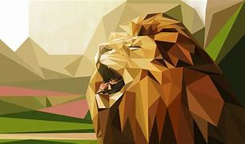

fig 1 Low-poly风

The implementation steps can be roughly divided into:

1.The Sobel operator is used to detect the edge of the grayscale image

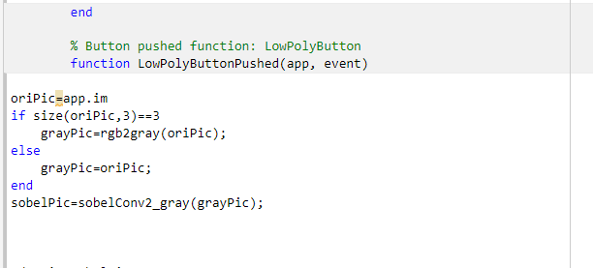

2. Because the feeling of low polyhedron is like a picture broken into many, many small pieces, and the easiest way is to divide the triangle to achieve the effect of subtracting the face. So we need to make the whole picture a picture with a lot of triangles. To do this, we first need to select random points on the image, here using the Poisson disk sampling algorithm to select random points.

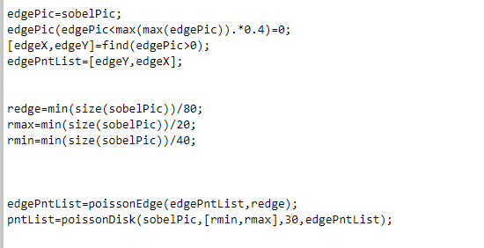

3.Then there is the triangular planing to achieve the effect of surface reduction

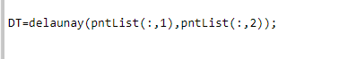

4.Finally, we color the triangle that we have divided, and we know the formula for the center of gravity of the triangle

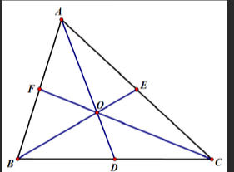(x1+x2+x3)/3, (y1+y2+y3)/3)

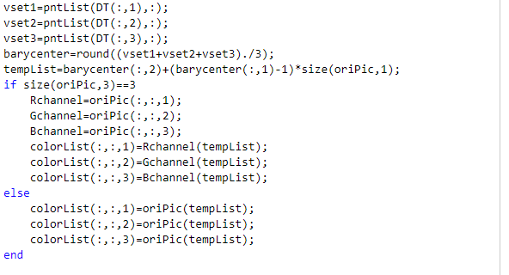Therefore, it is most appropriate to choose the center of each triangle section for coloring. So we use the center of gravity shading method of the triangle.

5.At this point, the low-poly stylization of the image has been completed. The rest of the work is to output the image.

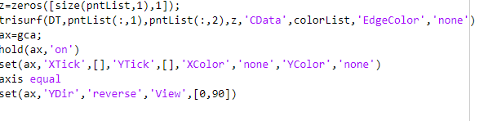Effect display

Original

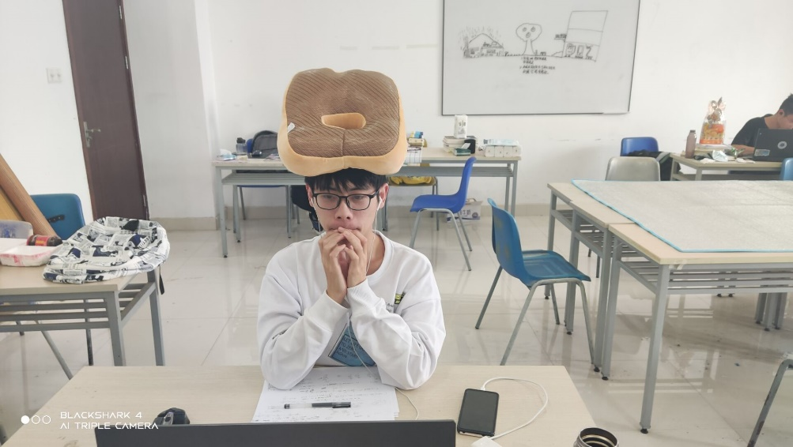

(With the consent of the person in question)

Renderings

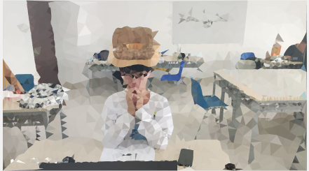

1.2 Face edge detection

1.2.1.

The idea of face recognition is to use skin tone recognition, so the first thing to do is to convert the image to the YCbCr type.

YCbCr where Y refers to the luminance component, Cb refers to the blue chromaticity component, and Cr refers to the red chroma component.

For Cr:144-160, make it 255, white, and the rest black:

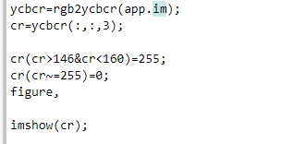

1.2.2

The image is then converted into a binary image, which facilitates the subsequent operation: distinguishing between faces and distractors

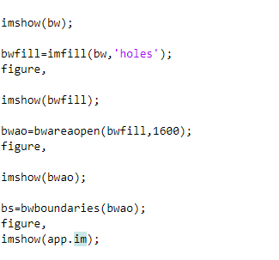

1.2.3

Finally, the images are screened again and a box is added to the detected faces.

bs=bwboundaries(bwao);

*bwboundaries* is a function that can be used to get the outline of an object in a binary graph, including the outer outline and the inner edge.

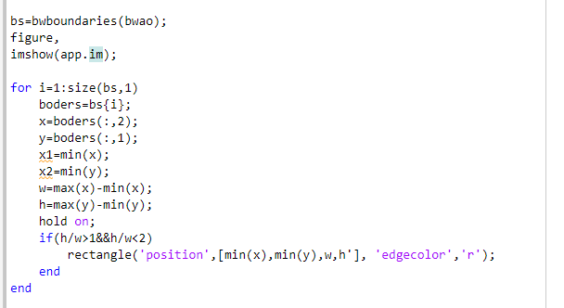

Effect display

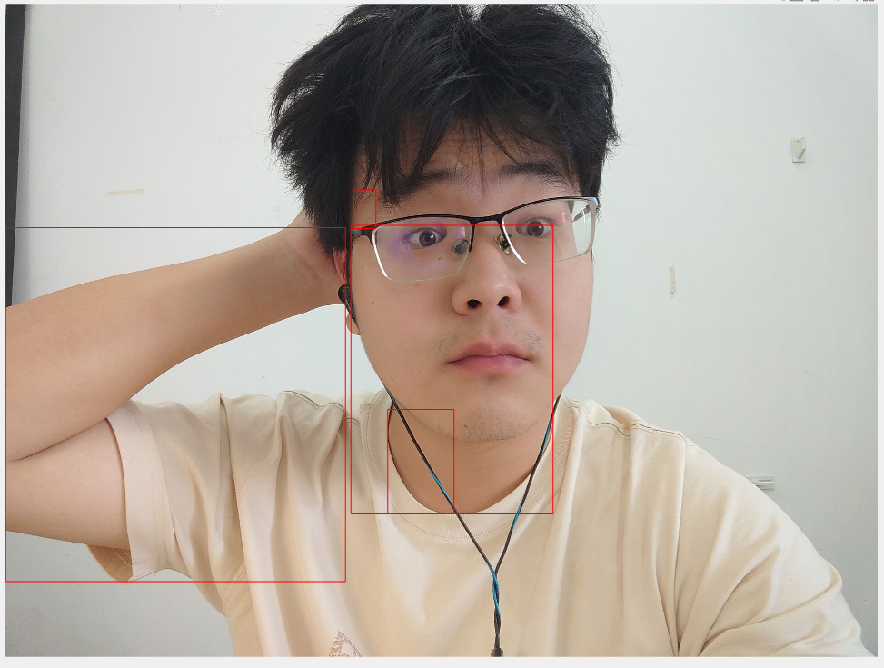 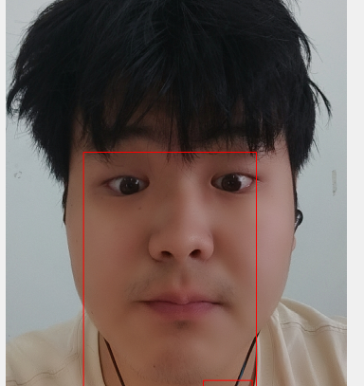

This is me, emmmm still has some errors according to the different pictures selected, which is also the shortcoming of this algorithm, and it needs to be improved in the future.

1.3 Interface design

The first is the design of the interface color,Considering this problem, I have been distressed for a long time,Unfortunately, my own art foundation is too poor,It seems that the color of how to adjust it is not good-looking,It affects the use of APP,So I remembered that last semester, in the course of modeling basics, the teacher recommended the "color pick" app to us when teaching us color matchingSo I chose a better color scheme to make my APP background color and button color

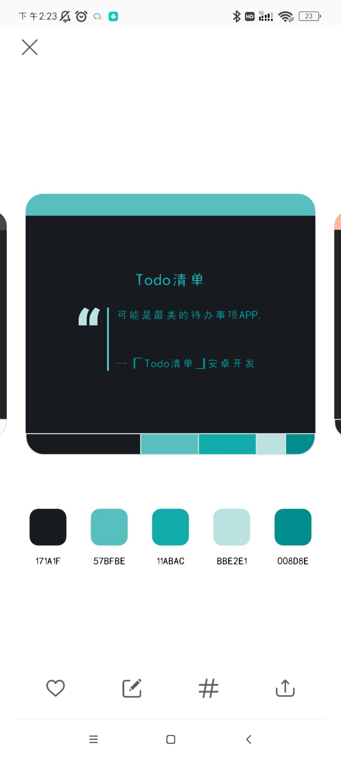

I picked two blue-green colors with RGB values of 87 191 190 and 0 141 142. Looking at the color is a bit like mint, summer is coming, and hopefully it will bring some refreshing feeling. At the same time, I also realized that choosing two colors with a small angle difference on the RGB color wheel seems to make the picture more natural, and this kind of low saturation and high brightness color can also make the picture softer.

Second, the purpose and significance of the design

Image processing refers to the technology of analyzing, processing, and processing images to meet visual, psychological, or other requirements. Image processing is an application of signal processing in the field of images. Most images are stored in digital form, so image processing is often referred to as digital image processing. A few decades ago, image processing was mostly carried out by optical devices in analog mode. Due to the inherently parallel nature of these optical methods, they still occupy a central position in many application areas, such as holographic photography. However, due to the rapid increase in the speed of computers, these technologies are rapidly being replaced by digital image processing methods. In a general sense, digital image processing technology is more universal, reliable, and accurate. They are also easier to implement than simulation methods.

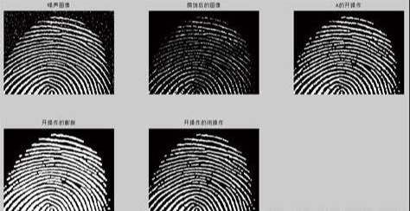

fig 2 Application of digital image processing technology

All kinds of digital images have long penetrated into all aspects of our lives, and are also widely used in aerospace, medical, military, crime fighting and other fields. As the saying goes, the eyes are the windows to the soul, and in this digital age, the viewport of our screen is our window, through which we see the world – and countless processed digital information floods into our minds. Digital images allow us to see the Sahara as far away, as well as the beautiful aurora and snow and ice. Digital images also allow us to deal with physical ailments and explore the vastness of the universe in a timely manner.

But back to each of us, digital images are photos shared in the circle of friends, retouching after each selfie, and beautification of each video. Simple, practical, and fun. Each picture carries our emotions, floats in the sea of the Internet, and links every island. I think that's the magic of digital images and digital image processing. In the same way, many of the functions we use can be achieved after a semester of study, so I chose to use MATLAB to develop a simple digital image processing system。 In addition to the basic functions required by the teacher, I also plan to add some content that I am interested in, whether it is a nice stylized treatment or a fun picture effect. The first is to test my learning results, and the second is to explore what I am interested in, my starting point is very simple, I hope that the digital image processing technology I have mastered through learning can add color, happiness or emotion to our ordinary life.

With the rapid development of the Internet, many studies on digital image processing have been carried out at home and abroad, and breakthroughs have been made in many fields. I was very interested in computer graphics last semester and digital image processing technology this semester, and the connection between these two courses made me deeply understand the charm of digital images. One of the reasons for my interest is that I personally love video games. I still remember the game footage I saw behind my father when I was a child. However, with the development of technology, the game graphics are becoming more and more beautiful and mature, and the game scene has become more realistic with the blessing of next-generation consoles and engines. At the same time, the development of graphics and engine technology has greatly promoted the development of the game industry, and the game industry has in turn promoted the development of graphics, which complement each other and provide more and more exquisite game graphics for players all over the world.

One of the things that struck me the most was the recent release of Unreal Engine 5, a major milestone for Unreal Engine, Epic Games' development tools for next-gen games, real-time visualization projects, and immersive interactive experiences. He will give developers across industries unprecedented levels of freedom, realism, and flexibility to develop next-generation 3D content and experiences.

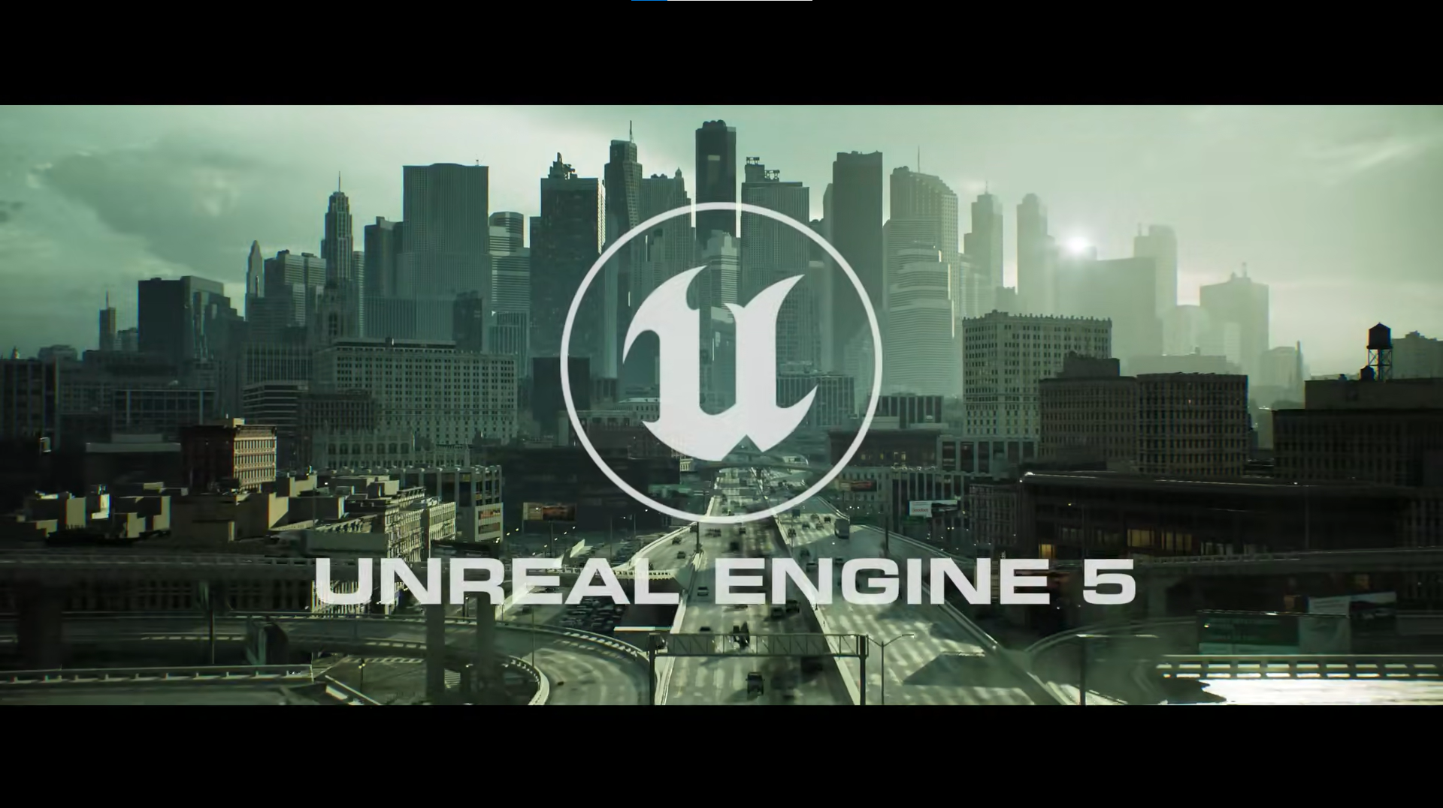

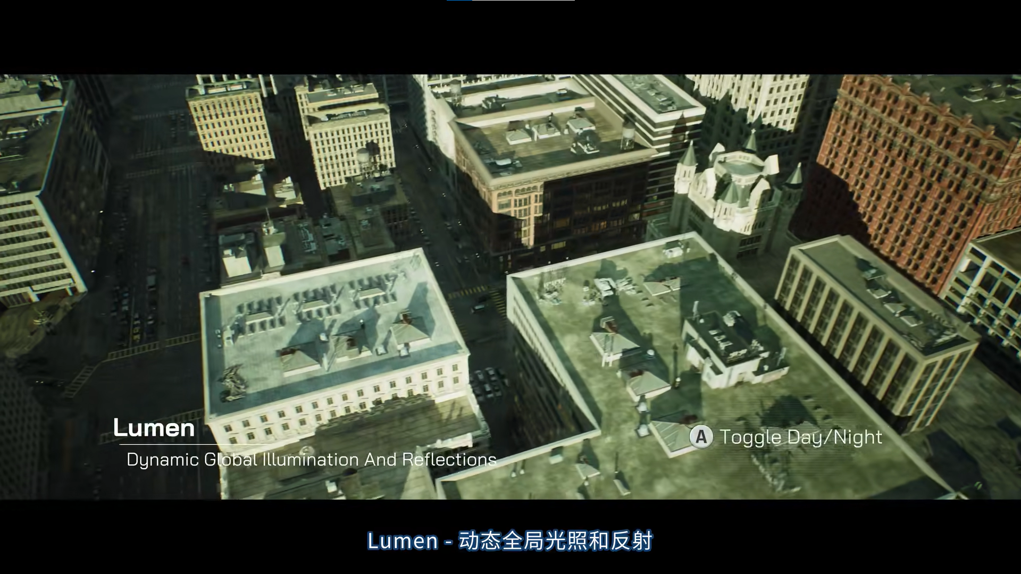

fig 3 Screenshot of the official UE5 demo

**Presumably, the advent of Unreal Engine 5 and its subsequent development will definitely bring new strength to the entire graphics processing industry. In the field of games that I am personally interested in, Unreal Engine's Lumen (Global Illumination technology) can save a lot of art work, taking textures as an example, in the past game production, many textures of 3D assets required a lot of effort and time from the relevant artists to draw. UE5's more sophisticated global illumination allows you to use the engine directly to represent the brightness and darkness of objects, saving you time and money.**

**And I believe that the development of engine technology will also promote the development of the metaverse, and maybe in the near future, we will be able to experience a different life in the virtual world just like in the movies.**

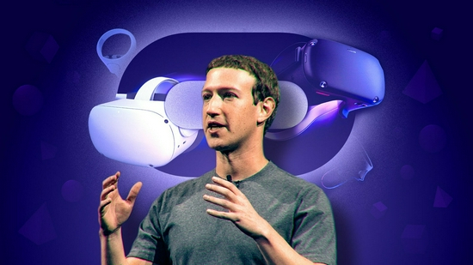

fig 4 Zuckerberg and the metaverse

**At the same time, in terms of digital image processing in China, I paid special attention to a big man in the industry who has very powerful engine technology - Mao Xingyun. Mao Xingyun (1991-December 11, 2021), network ID "Qianmo", post-90s, Microsoft's most valuable expert, Tencent Games Lead Engine Programmer, that is, the engine development team leader. I read some of the articles written by this expert in the field of digital image processing, and they are a bright beacon for many beginners who want to enter the field of engines and games. At the same time, while working diligently, this big guy is still continuing to translate and add Chinese versions to excellent foreign language learning materials.**

**He has also published many high-quality tutorials on CSDN, Zhihu, etc., and has worked hard and attentively to guide every beginner. I still remember that the word "light ink" appeared on the screen when the teacher displayed the courseware, which was Mr. Mao Xingyun's nickname. On the title page of my own notebook there is always the following sentence: "An idealist must have character in order not to be corrupted by power, and an idealist must have the ability to translate ideals into practice." But an idealist who has both character and ability, Jixi. "I think Mr. Mao Xingyun is a truly good idealist. I still think that there is no shortage of people with extreme personal ability in this world, and there is a need for more navigators, more people who can unite the scattered people. More people who can bring the flames together to form a warm campfire.**

**But the sad thing is that Mr. Mao Xingyun's life is forever fixed at the age of 30, and on December 11 last year, he left this world forever. In his own C++ notes, he copied the phrase "One day you will break out of the chrysalis and grow more beautiful than people expect." The process can be painful, hard, and sometimes discouraged. In the face of the surging reality, I feel small and powerless. But it's also a part of life. Do what you can do now, and then, everything will be fine. We will all grow up alone, don't be afraid. "I learned about Mr. Mao Xingyun when I was studying graphics research materials last semester. It was his spirit and passion that ignited my interest in studying digital image processing and graphics. At the same time, it also gives me hope and expectation for my country's game industry.**

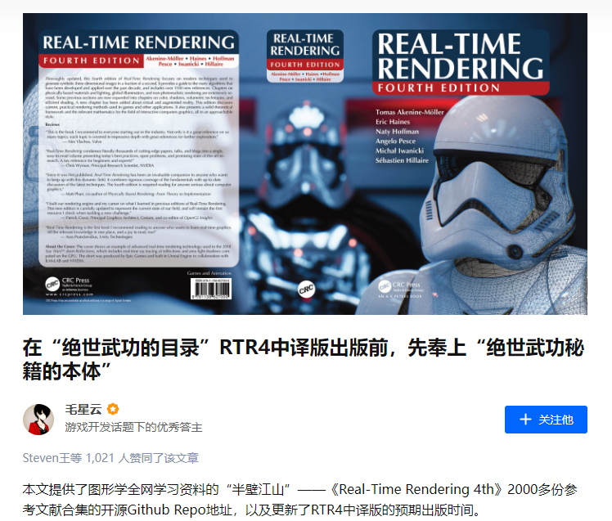

fig 5 Mao Xingyun's article published on Zhihu

Third, the overall scheme design

**3.1 Division of functional modules**

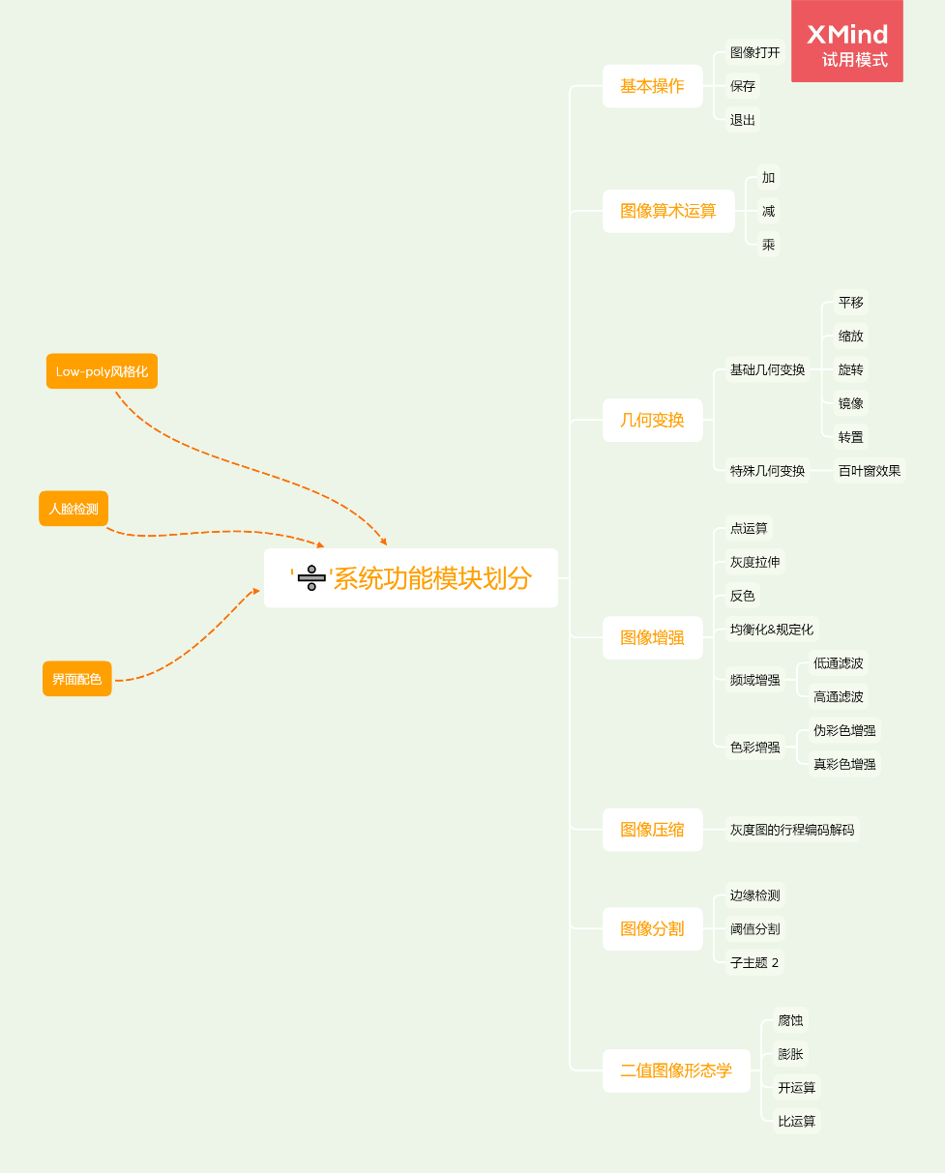

**3.2 System Framework Diagram**

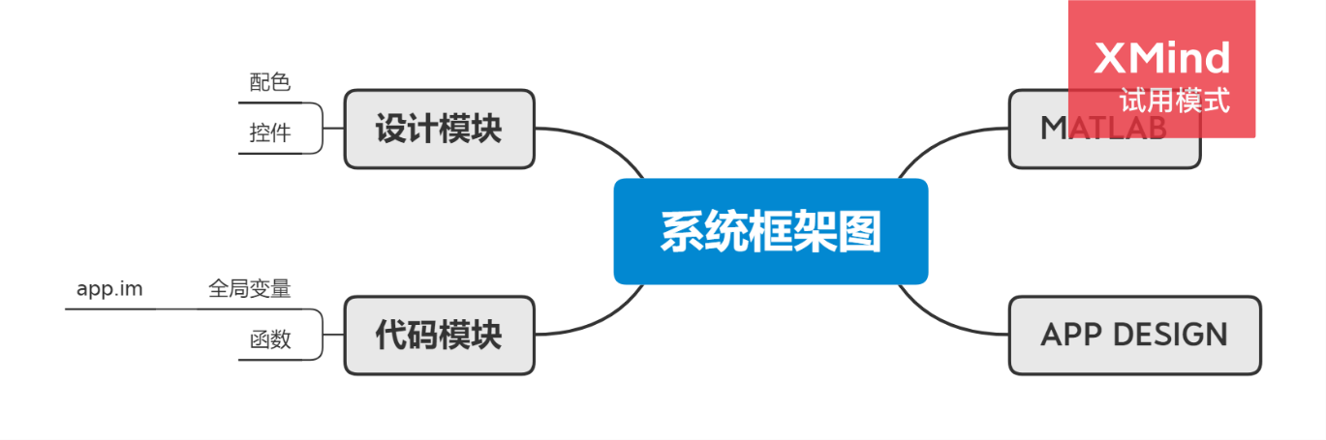

**3.3 Flowchart**

**3.4 The operating environment of the system**

**Operating System:** 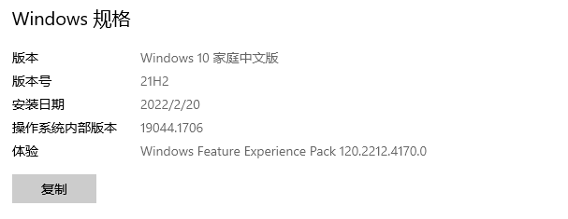

Hardware system:

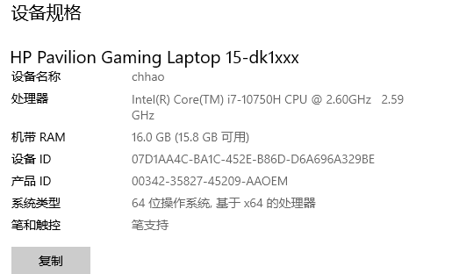

**3.5**

**选用的工具：MATLAB R2020b APP DESIGN**

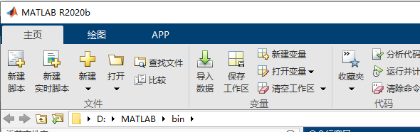

**3.6**

**For details of the implementation principle, please refer to the fourth part of the "main implementation procedures of each functional module"**

**Fourth, the main implementation procedures of each functional module**

**4.1**

**Open, save, and exit image files (BMP, JPG, etc.);**

**Open it:**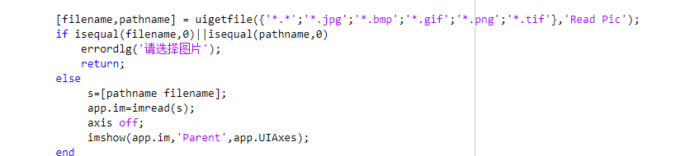

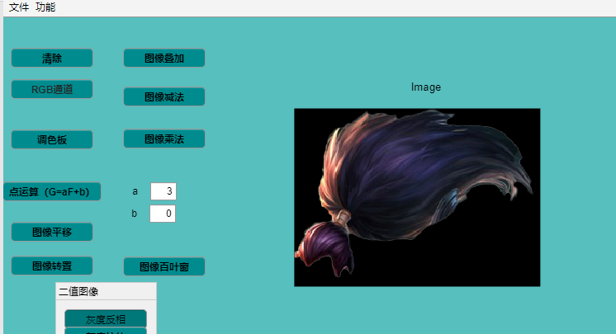



**The code that opens an image should list a variety of image formats to improve the fault tolerance of the system. At the same time, I added the decision not to select the image, which can also make the system more reasonable**

**Save:**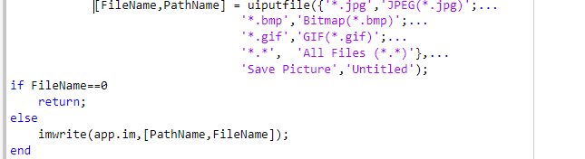

**4.2 Arithmetic operation of images: realize the addition, subtraction and multiplication of two images**

**The addition of an image is to superimpose the contents of one image on top of another, or to add a constant to each pixel of the image to change the brightness of the image. (It should be noted that the image data type in Matlab is unit8, and overflow may occur when performing algebraic operations, so convert the data type of the image to double before algebra operations.)**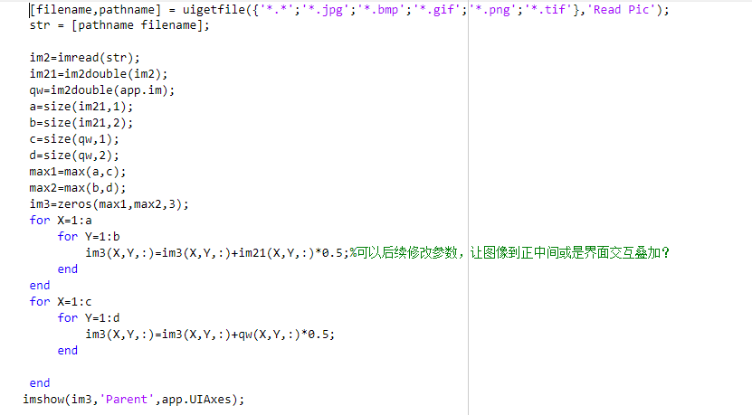

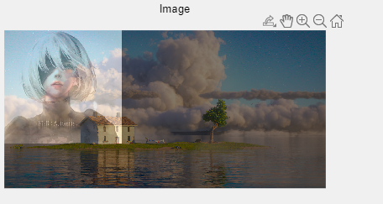

**Image subtraction is the subtraction of the corresponding pixels between two images. Image subtraction can detect the difference information between two images, just like the teacher talked about in class, and can realize the detection of monitoring screens.**

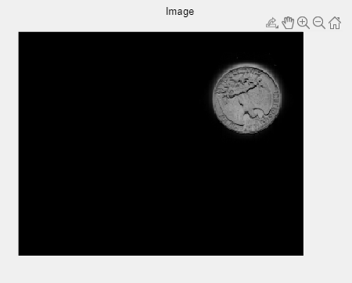

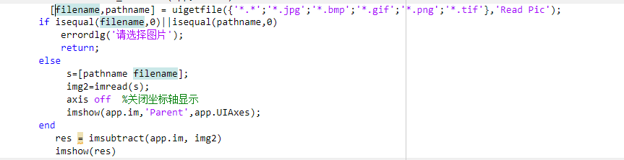

**Multiplication refers to the dot multiplication of matrix elements and is used for mask manipulation or brightness adjustment.**

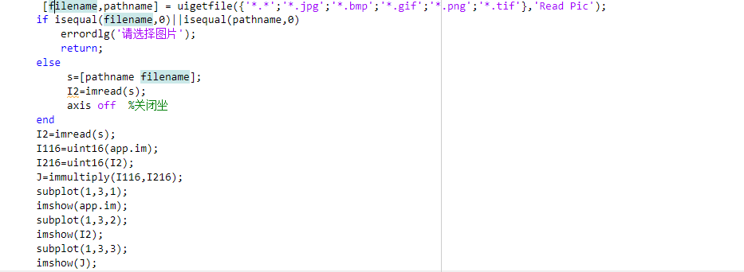

**4.3 Geometric transformations**

**An image geometric transformation, also known as an image space transformation, maps a coordinate position in one image to a new coordinate location in another image. When we learn geometric transformations, we determine this spatial mapping and the parameters that change in the mapping process. The geometric transformation of the image changes the spatial position of the pixel, and establishes a mapping relationship between the original image pixel and the transformed image pixel, through which the following two calculations can be realized: For the first calculation, as long as any pixel coordinates on the original image are given, the coordinate position of the pixel in the transformed image can be obtained through the corresponding mapping relationship.**

**(1) Translation, zooming, rotation, mirroring, transposing, etc. of the image**

**4.3.1 Translation is to add and subtract from the x,y coordinates of each pixel.**

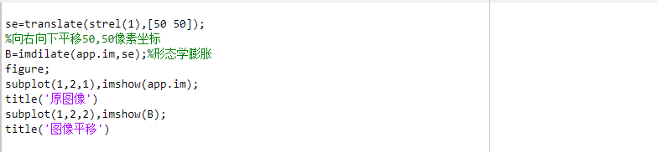

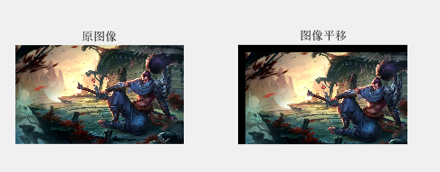

**4.3.2 Scaling**

**Here I also set a variable to control the zoom multiplier, the user only needs to enter the number in the visual interface to control the zoom size.**

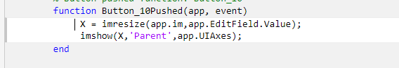

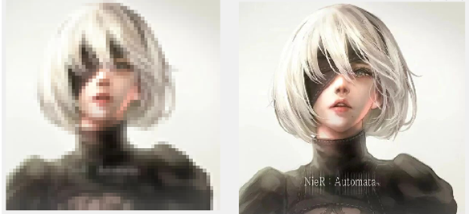

**4.3.3 Rotation**

**The rotation of the image also involves the problem of interpolation, and in the first experiment of the semester I explored the differences between several interpolation methods.** 1.Nearest-neighbor interpolation



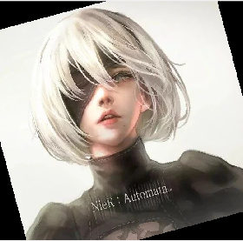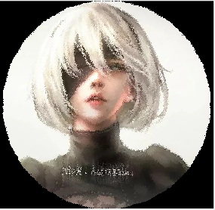  
 2.双线性插值（Bilinear interpolation）

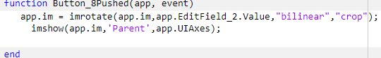

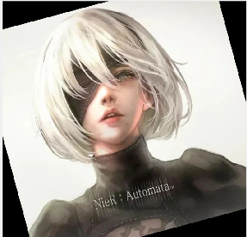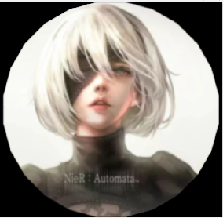

3． 双三次插值（Bicubic interpolation）

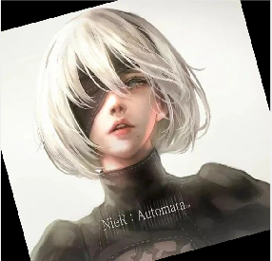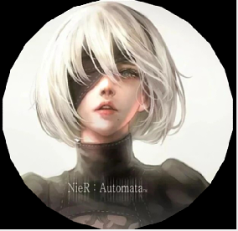

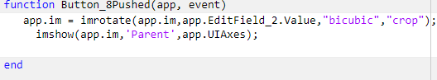

**I compared the interpolation of the three image rotations, one rotation at 15° each rotation and one rotation (24 times) of the sharpness of the image. The comparison shows that the difference between the first rotation is not large, but after one rotation, the clarity gap of the three experiments is large, among which the bicubic interpolation is the best, and the human eye can not see the obvious blur, and the nearest linear interpolation is the worst, which can be seen to be obviously blurred. The final image is round because the window crops the invisible part when it is rotated, and after one rotation the image is cropped into a circle.**

**4.3.4 Mirroring;**

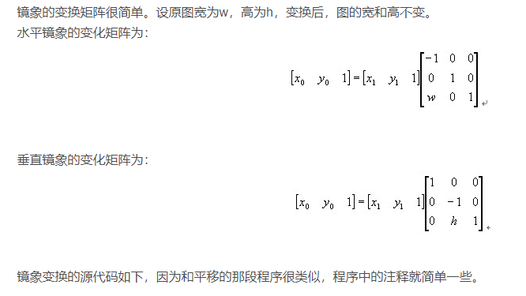

fig 6 A blogger's explanation of mirroring

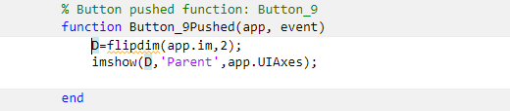

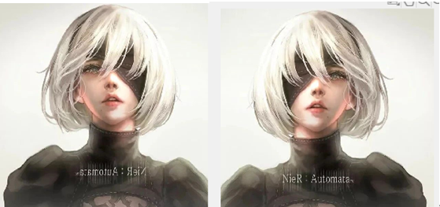

**4.3.5 Transpose**

**Image transpose refers to the swapping of the x and y coordinates of an image pixel.**

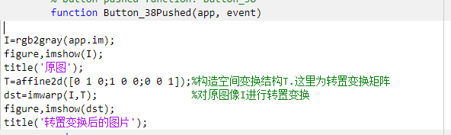

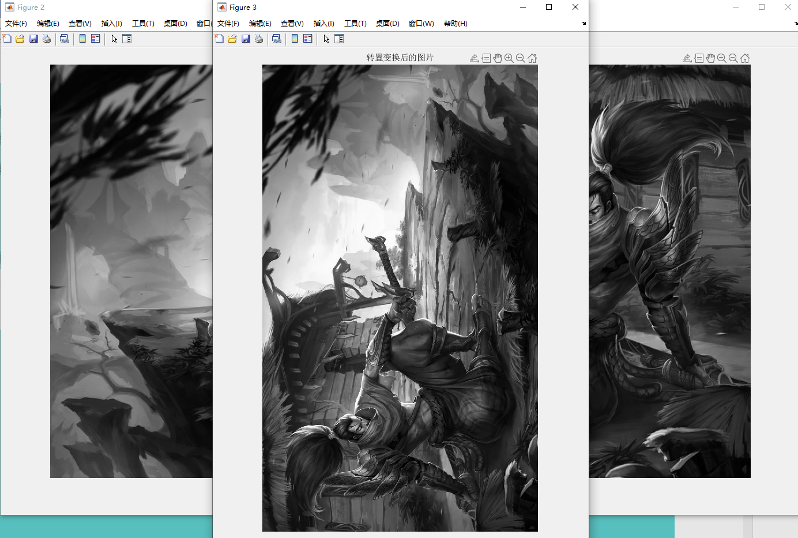

**(2) Special geometric transformations, such as blinds effect.**

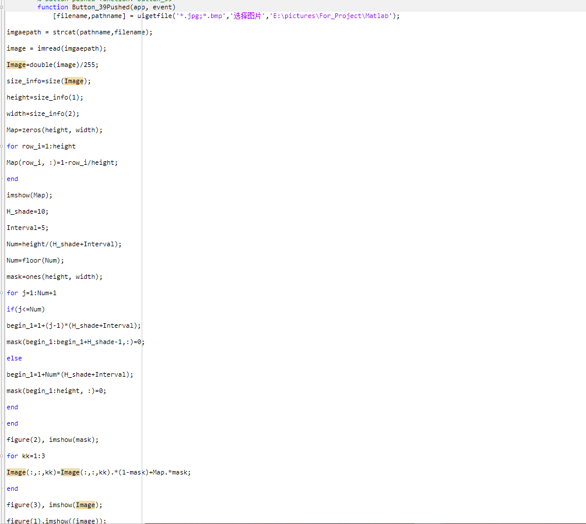

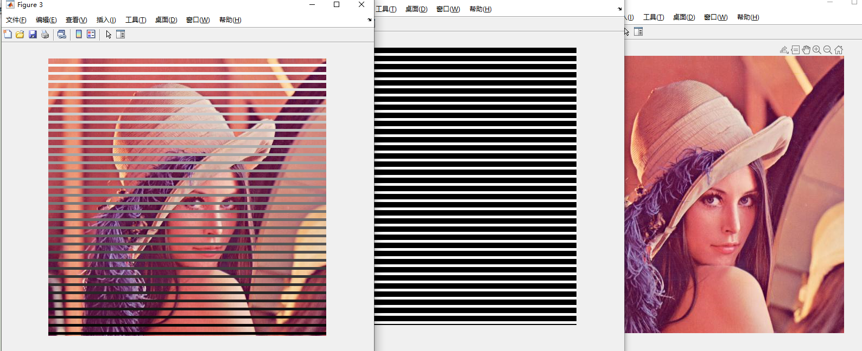

**4.4 Image Enhancement**

**4.4.1 Point operation: Point operation is also called contrast enhancement, contrast stretching, gray transformation, etc. Form e.g. A(X,Y)=f(B(X,Y)). A is the output image pixel and B is the input image pixel.**

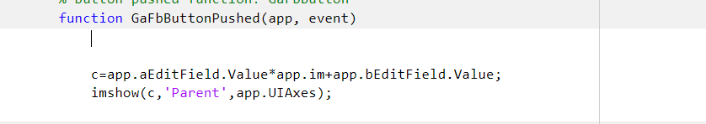

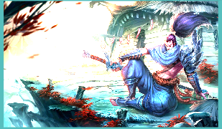

**4.4.2 Binary image processing**

**Binary image processing includes three functions, grayscale inversion, grayscale stretching, and grayscale compression.**

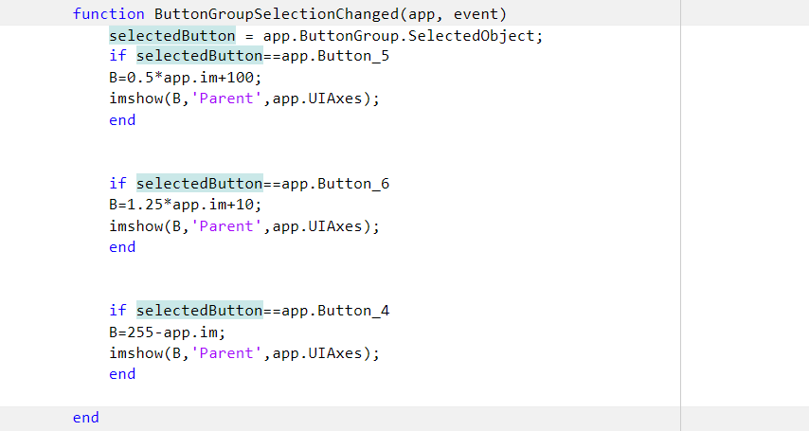

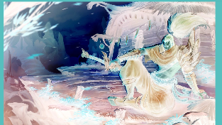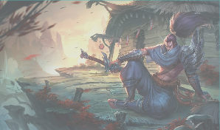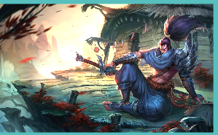

**4.4.3 Equalization and prescription of histograms;**

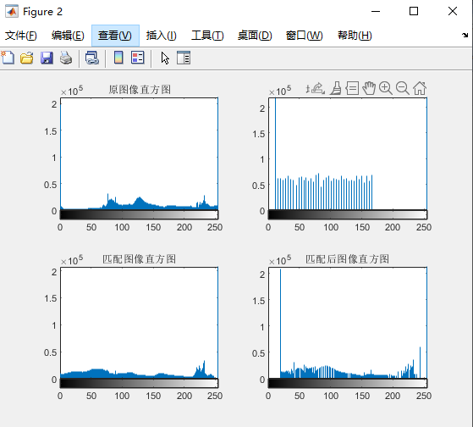

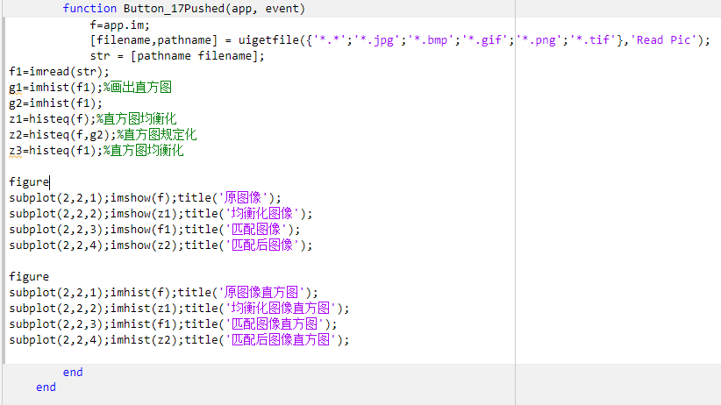

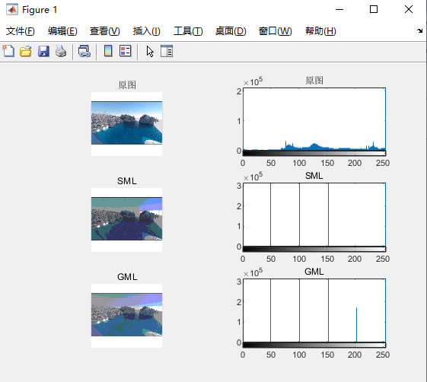

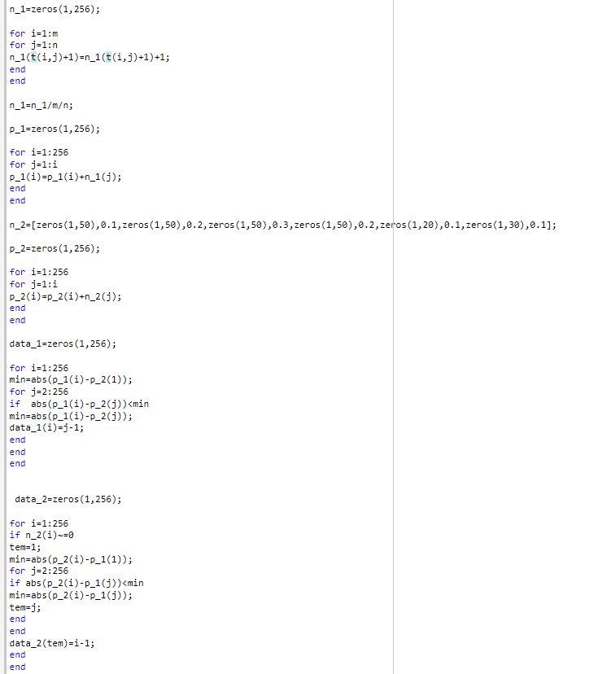

**4.4.4 Spatial domain smoothing algorithm**

**Median filtering**

Median treatment of salt-and-pepper noise

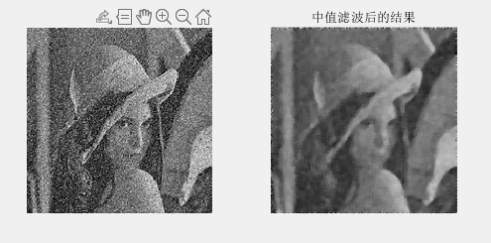

The median values deal with Gaussian noise

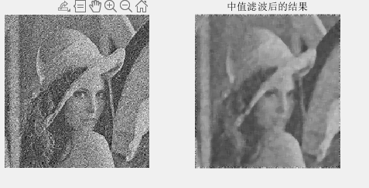

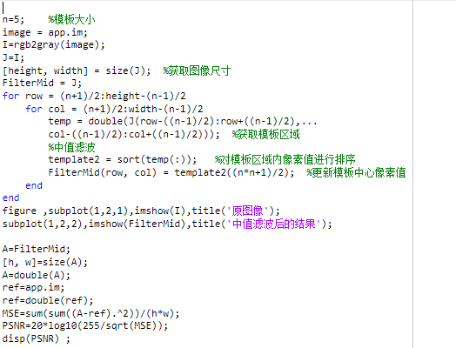

**Mean filtering**

First, the mean filtering is used to deal with the salt and pepper noise.

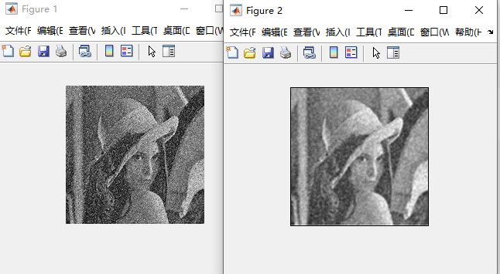

Then there is mean filtering to deal with Gaussian noise.

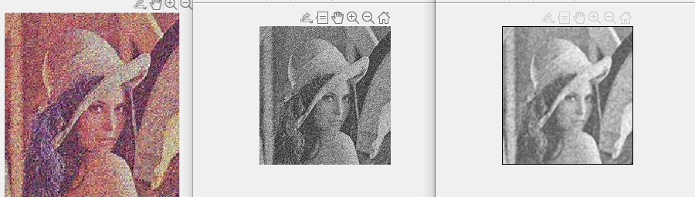

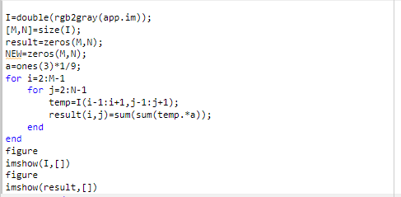

**4.4.5 Frequency domain enhancement: low-pass filtering, high-pass filtering, etc.;**

**Low-pass filtering**

Ideal low-pass filter

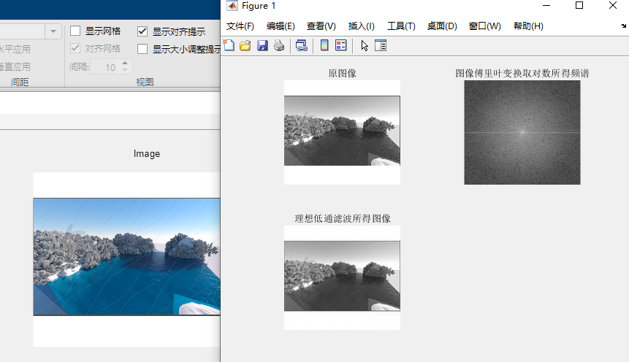

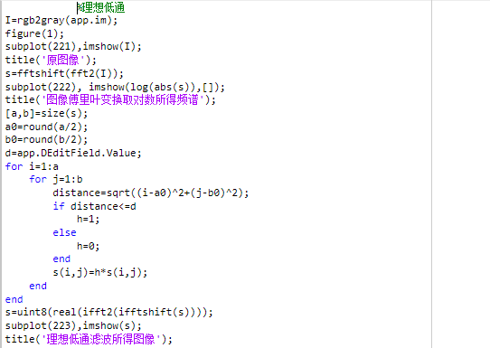

Butterworth low-pass filtering

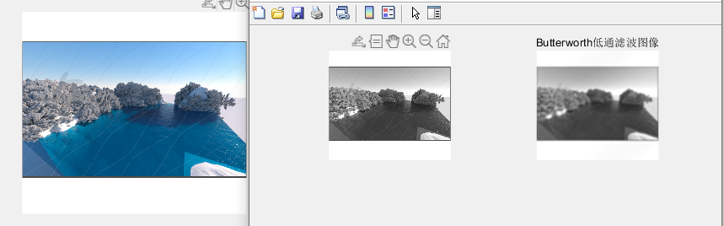

%Butterworth Low Pass

figure(2);

I=rgb2gray(app.im);

subplot(221),imshow(I);

title('原始图像');

f=double(I);% data type conversion

g=fft2(f);%Image Fourier Transform

g=fftshift(g);%傅里叶变换平移

F2=log(abs(g));% takes the absolute value of the Fourier transform result, and then the logarithm

[N1,N2]=size(g);% Fourier transform image size

n=app.nEditField.Value;The % parameter is assigned an initial value

d0=app.d0EditField.Value;

n1=fix(N1/2);% Data rounded

n2=fix(N2/2);% Data rounded

for i=1:N1%遍历图像像素

for j=1:N2

d=sqrt((i-n1)^2+(j-n2)^2);

if d==0

h=0;

else

h=1/(1+(d/d0)^(2*n));

end

result(i,j)=h*g(i,j);Image matrix calculation and processing

end

end

F3=log(abs(result));% takes the absolute value of the Fourier transform result, and then the logarithm

result=ifftshift(result);

X2=ifft2(result);

X3=uint8(real(X2));

subplot(222),imshow(uint8(X3))

title('Butterworth低通滤波图像');

**High-pass filtering**

Ideal Qualcomm

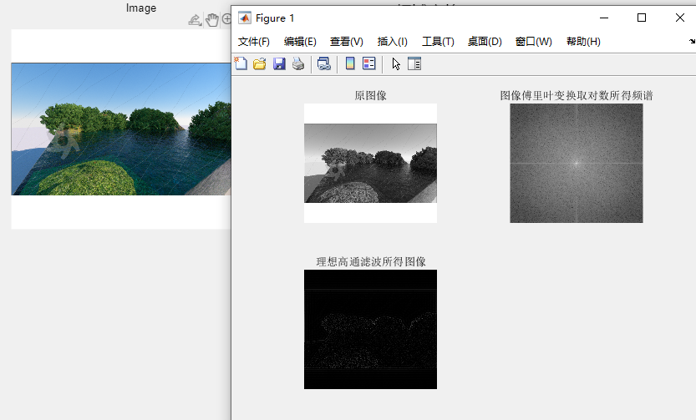

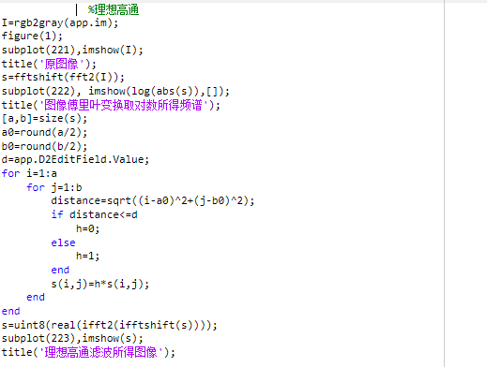

Butterworth Qualcomm

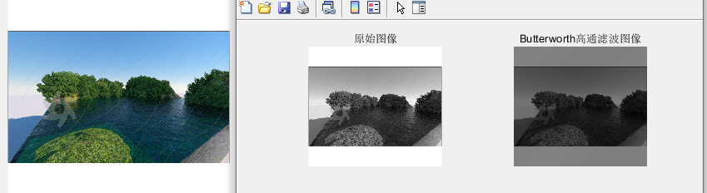

%Butterworth Qualcomm

figure(2);

I=rgb2gray(app.im);

subplot(221),imshow(I);

title('原始图像');

f=double(I);% data type conversion

g=fft2(f);%Image Fourier Transform

g=fftshift(g);%傅里叶变换平移

F2=log(abs(g));% takes the absolute value of the Fourier transform result, and then the logarithm

[N1,N2]=size(g);% Fourier transform image size

n=app.nEditField.Value;The % parameter is assigned an initial value

d0=app.d0EditField.Value;

n1=fix(N1/2);% Data rounded

n2=fix(N2/2);% Data rounded

for i=1:N1%遍历图像像素

for j=1:N2

d=sqrt((i-n1)^2+(j-n2)^2);

if d==0

h=0;

else

h=1/(1+(d0/d)^(2*n));

end

result(i,j)=h*g(i,j);Image matrix calculation and processing

end

end

F3=log(abs(result));% takes the absolute value of the Fourier transform result, and then the logarithm

result=ifftshift(result);

X2=ifft2(result);

X3=uint8(real(X2));

subplot(222),imshow(uint8(X3))

title('Butterworth高通滤波图像');

**4.4.6 Color Enhancement: False Color Enhancement True Color Enhancement.**

**False Color Enhancement:**

**gray=rgb2gray(app.im);**

**[h,w]=size(gray);**

**NewImage3=zeros(h,w,3);**

**for x=1:h**

**for y=1:w**

**if gray(x,y)<96**

**NewImage3(x,y,1)=0;**

**elseif gray(x,y)<128**

**NewImage3(x,y,1)=255*(gray(x,y)-96)/32;**

**else**

**NewImage3(x,y,1)=255;**

**end**

**end**

**end**

**for x=1:h**

**for y=1:w**

**if gray(x,y)<32**

**NewImage3(x,y,2)=0;**

**elseif gray(x,y)<64**

**NewImage3(x,y,2)=255*(gray(x,y)-32)/32;**

**elseif gray(x,y)<128**

**NewImage3(x,y,2)=255;**

**elseif gray(x,y)<192**

**NewImage3(x,y,2)=255*(192-gray(x,y))/64;**

**else**

**NewImage3(x,y,2)=255*(gray(x,y)-192)/64;**

**end**

**end**

**end**

**for x=1:h**

**for y=1:w**

**if gray(x,y)<32**

**NewImage3(x,y,3)=255*gray(x,y)/32;**

**elseif gray(x,y)<64**

**NewImage3(x,y,3)=255;**

**elseif gray(x,y)<96**

**NewImage3(x,y,3)=255*(96-gray(x,y))/32;**

**elseif gray(x,y)<192**

**NewImage3(x,y,3)=0;**

**else**

**NewImage3(x,y,3)=255*(gray(x,y)-192)/64;**

**end**

**end**

**end**

**subplot(121)**

**imshow(NewImage3);**

**True color enhancement**

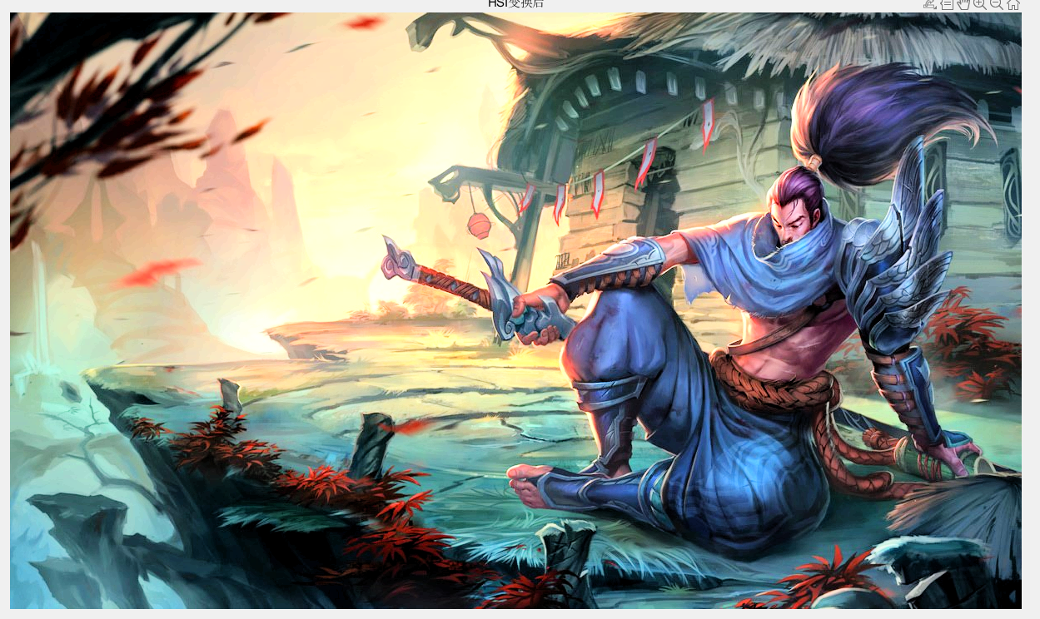

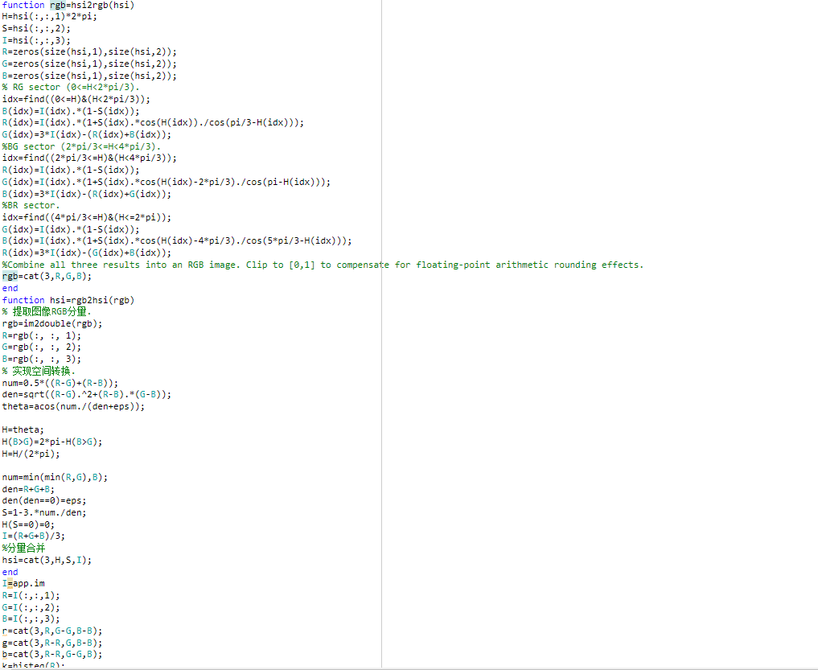

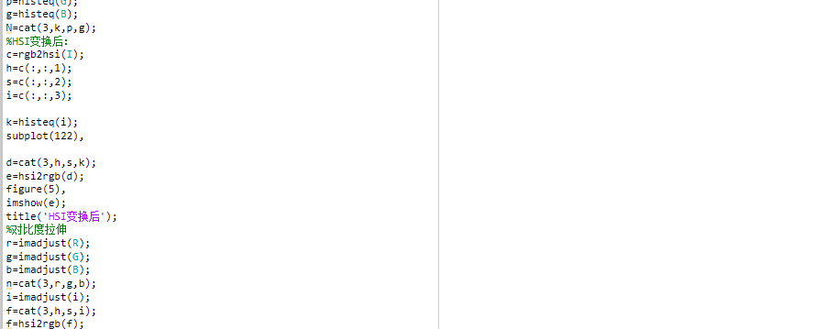

**4.5**

**Image compression**

**(1) The encoder algorithm and decoder algorithm of grayscale image or color image are realized by using the stroke coding algorithm. Encoder and decoder for grayscale images**

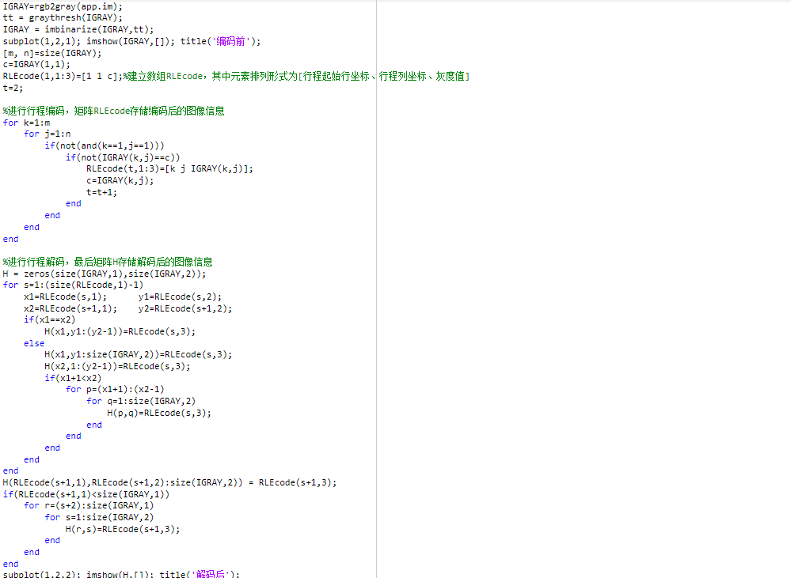

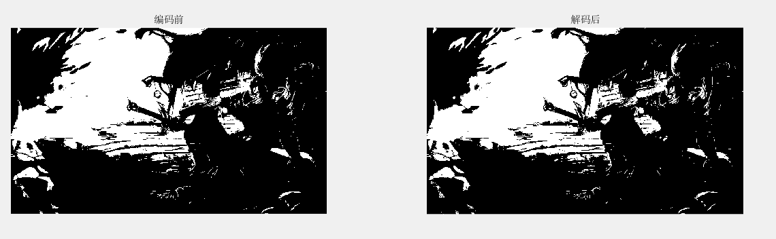

**4.6 Image segmentation**

**4.6.1**

**Edge detection**

**1.** Roberts算子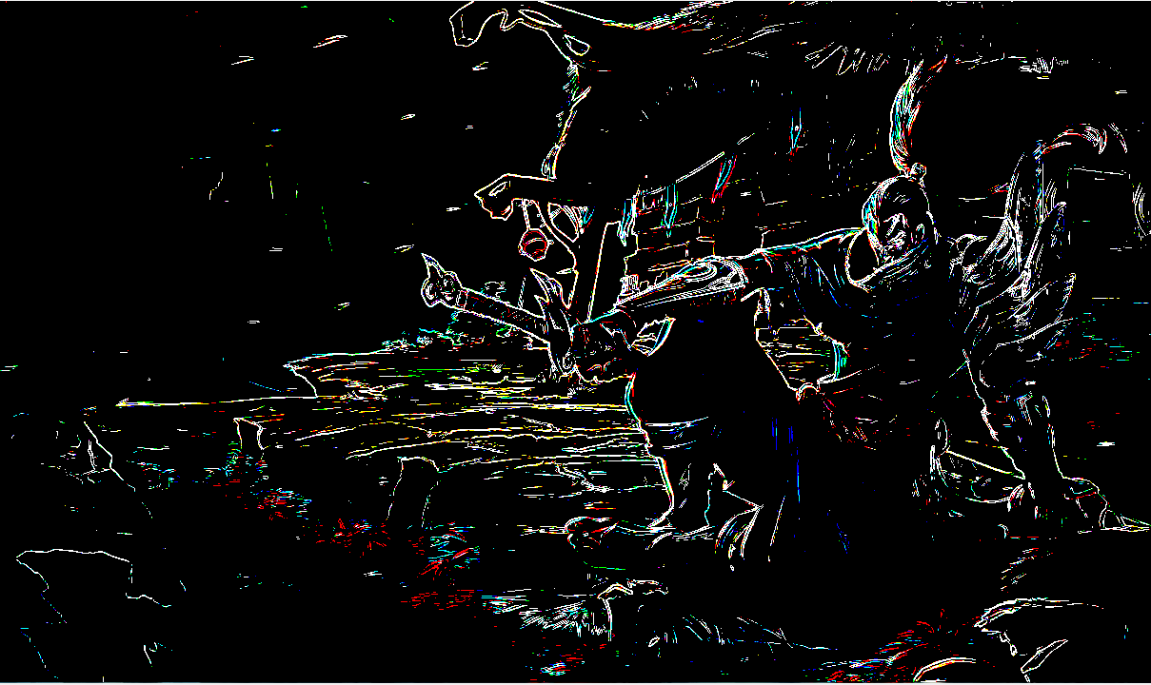

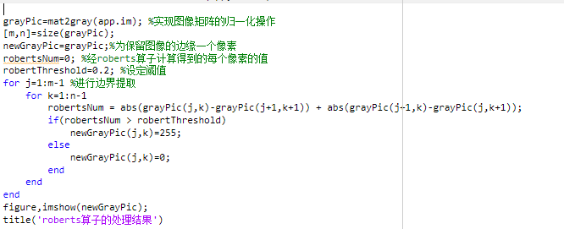

**2.Sobel算子**

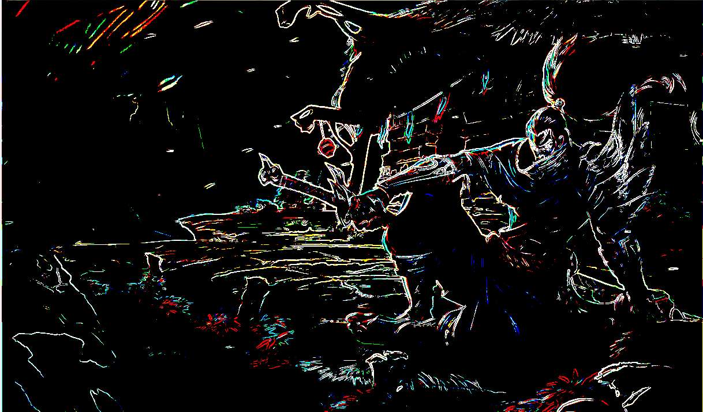

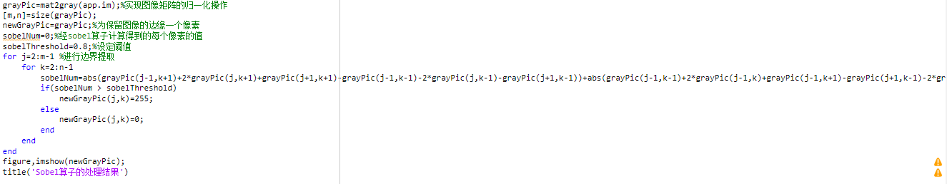

**3.Prewitt算子**

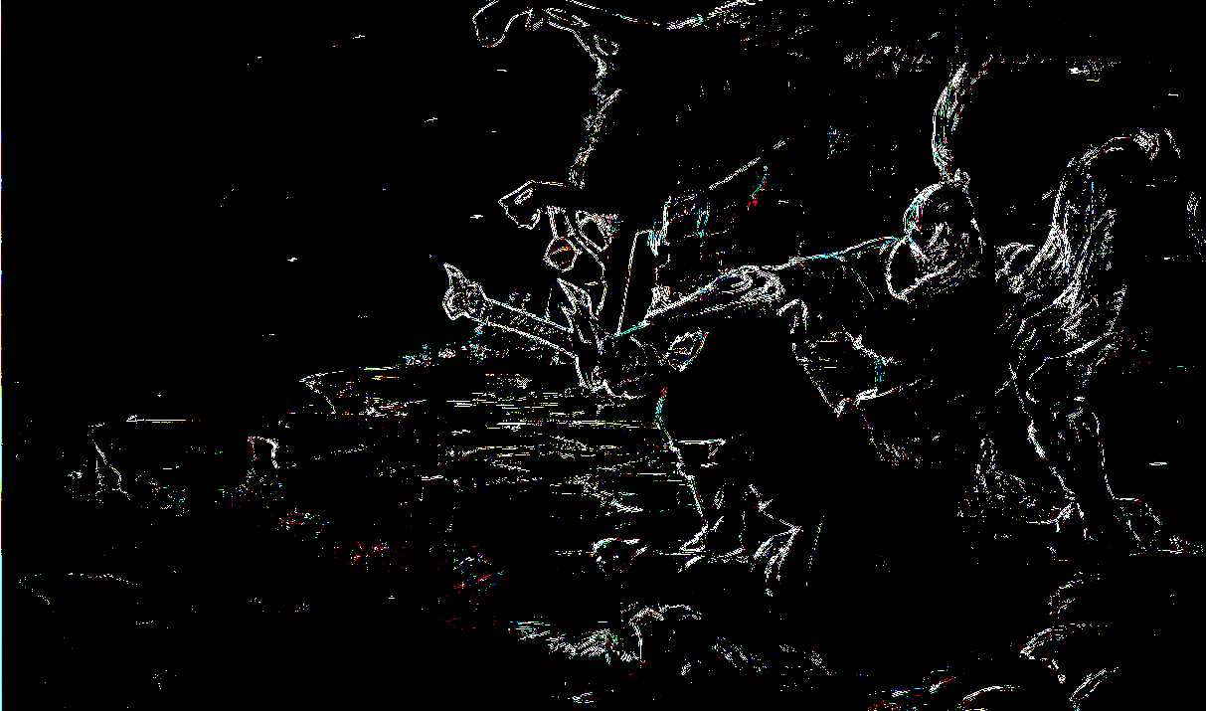

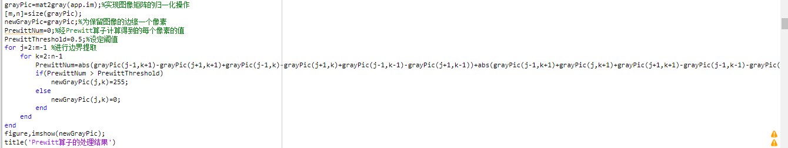

**4.Laplace算子**

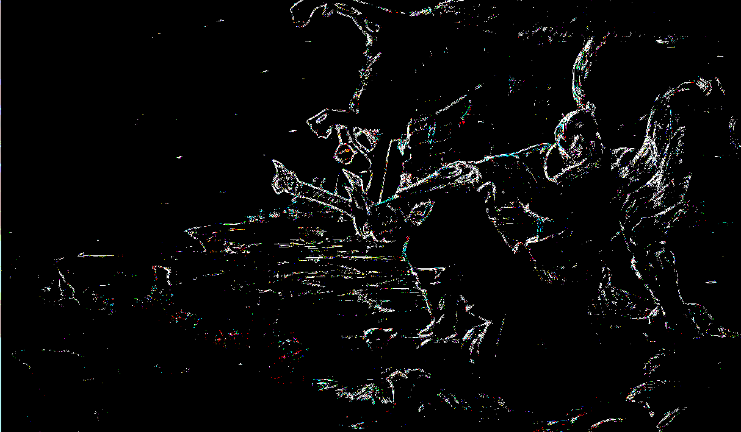

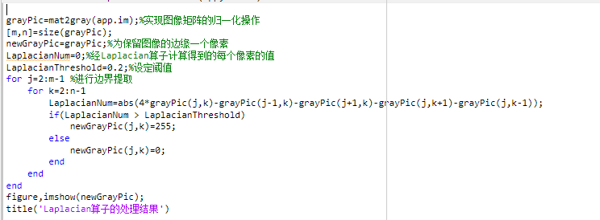

**4.6.2 Threshold segmentation**

**a) interactive threshold segmentation;**

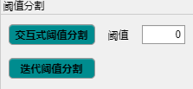

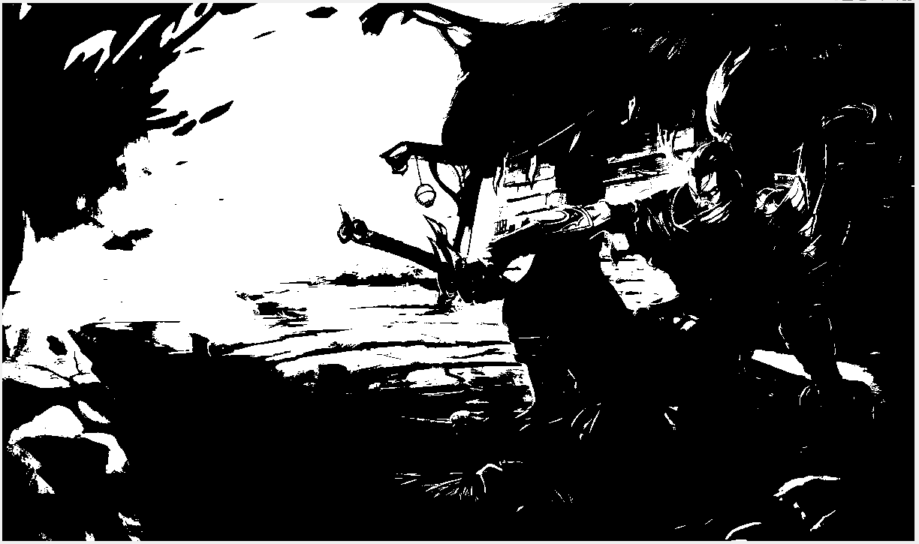

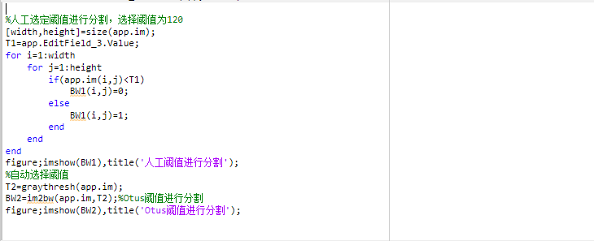

**b) Iterative threshold segmentation method.**

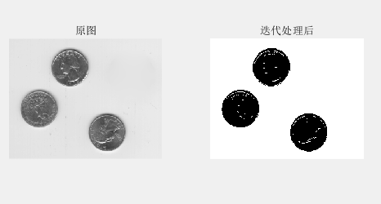

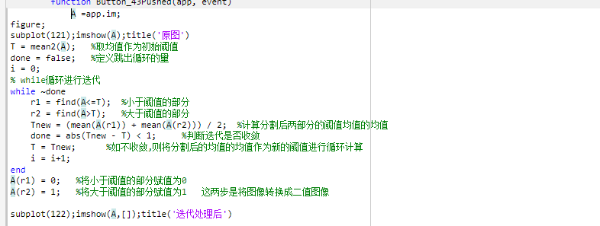

**4.7** Binary Image Morphological Processing:

4.7.1 Corrosion

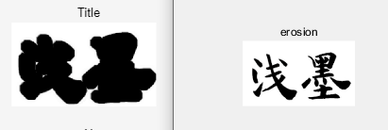

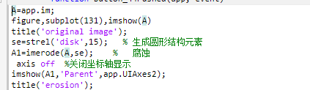

4.7.2 Expansion

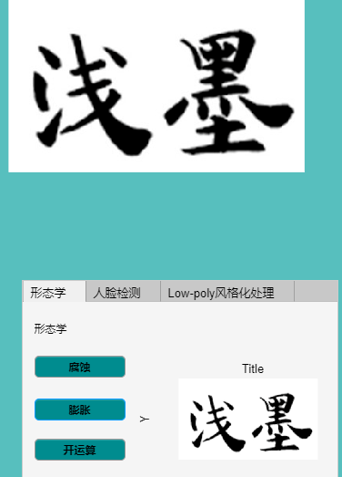

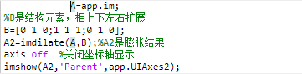

4.7.3 Operation

Open = Corrosion first, then expansion (seems to separate two targets that are subtly connected)

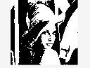、

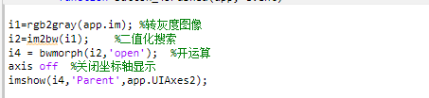

4.7.4 Closed operations

Closed = Dilation followed by corrosion (appears to enclose two finely connected tiles together)



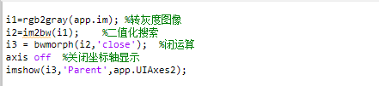

**5. Summary and experience of course design**

**Everything is difficult at the beginning, and I have always felt that there are two most difficult things to learn a new thing, one is the construction of the knowledge system at the beginning, and the other is the reflection and persistence of subsequent learning. Luckily, I met a teacher who was enthusiastic and responsible. It opened the door to digital image processing learning with me. Moreover, the many amazing people in this industry and the classmates who have been with me during my study have also given me great motivation to learn, so that I can persevere on the road of learning digital image processing. At the same time, there are many ways to learn, in addition to laying a solid foundation in the classroom, we can also continue to broaden our knowledge by reading papers, watching video tutorials, etc., and learn various knowledge in related fields.**

**Through the study of digital image processing technology this semester, I have learned a lot of knowledge related to digital images, and I am very interested in many of the knowledge taught by the teacher.**

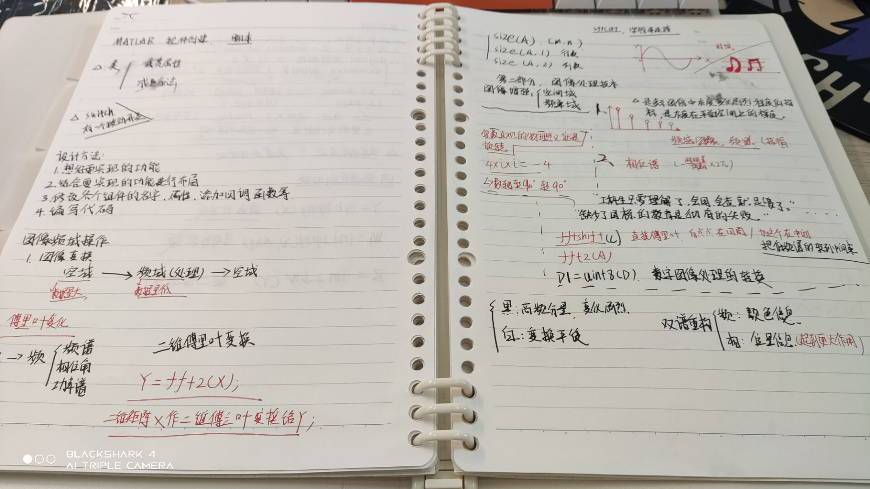

fig 7My digital image processing notes

**My knowledge of digital image processing is also filled with my own knowledge matrix from scratch, addition, subtraction, multiplication, division, and division. It built my body of knowledge as a beginner. Although there are a lot of loopholes, what I see through them is something more interesting in digital image processing, something that is more interesting, more complex, and more difficult to understand. Although these things are still very difficult for me now, I believe that one day I will grasp some of them. When I've absorbed enough nutrients on the way to continue my studies, I'll be grateful for the day I first encountered graphics and digital image processing.   
 Foreign Unreal and Unity engines lead the industry. Domestic rendering and engine technology is also constantly developing, but it still needs the efforts of our generation of young people. For me, the game industry is the direction of my future efforts, I believe that in my future study and life, and I am also very grateful to Mr. Di Lan for teaching me, which opened the door to my digital image processing, and I believe that it will be of great benefit to my future study, work and life. Finally, I would like to end with a passage from Mr. Mao Xingyun**

**"I have a dream that one day in the future, domestic games will be like other industries in China, facing the world and the whole universe with a leading attitude. It's a dream that we'll accomplish together.   
I await our good news. ”**

**6. References**

**[1] Wikipedia:Definition of image processing**

**[2] Zhihu: How to evaluate**

**UE5https://www.zhihu.com/question/394668845/answer/2433734466**

**[3].百度百科：毛星云**

<https://baike.baidu.com/item/%E6%AF%9B%E6%98%9F%E4%BA%91/14187860>

**[4]CSDN ：MATLAB图像的几何变换**

<https://blog.csdn.net/Bryan_QAQ/article/details/78728974>

**[5] Yang Tiancheng.MATLAB-based face recognition attendance system[J].Computer Fan,2016(10):77+14**

**[6] Yuan Yangyu. Research on quality assessment algorithm in face recognition[D].Chongqing University of Technology,2016**

**[7] Li Jinxu. Research on face recognition algorithm based on NSCT transform and deep learning neural network[D].Harbin University of Science and Technology,2016**

**[8] Zeng Zhichao. Research on face recognition system based on wavelet theory[D].Shanghai Jiao Tong University,2016.DOI:10.27307/d.cnki.gsjtu.2016.000450**

**[9] Tian Zheng. Design and implementation of access control system based on face recognition[D].Shanghai Jiao Tong University,2016.DOI:10.27307/d.cnki.gsjtu.2016.000623**

**[10] Dong Lu. Development of digital image processing and recognition system[D].Southeast University,2004**

**[11]Bilibili MATLAB GUI <unk>学 <unk> <unk>。**

**https://www.bilibili.com/video/BV1mJ411G7TY?spm_id_from=333.337.search-card.all.click**